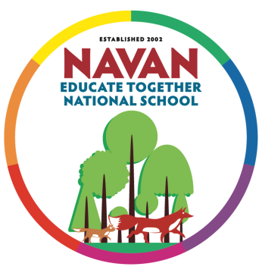
Newsletter
10.03.2023

Assembly
1st Class hosted todays assembly all about Spring. They told us all about the signs of spring and how lovely it is when we start to see new life springing up around us. We were also treated to a lovely song called Spring is Here! Well done 1st Class.
The PTA held a coffee morning for parents who attended the assembly this morning. Thank you to the PTA for providing this opportunity for parents to mingle with other parents.

Aldi Stickers
Thank you for your support in the collection of the Aldi Play Rugby Stickers. The children have been busy sticking them to our big posters. The more posters we can fill the more chances we have of winning! Collecting these stickers gives the school a chance to win a top prize of €50,000, or other prizes of €5000, to spend on school playing facilities. If you currently shop at Aldi, please collect these stickers at the till.

School Photos
County Photos were in the school this week to take the annual school photographs. The day ran smoothly with huge thanks to the PTA and the parents who came in on the day to help out. The photographer will return to the school on a date to be confirmed to take the remaining photographs.

World Book Day – Decorate Your Door Competition
The Student Council ran a Decorate Your Door competition in the school as part of our World Book Day activities. There were some amazing and creative doors on display, from The Very Hungry Caterpillar, The Twits, Holes, Where’s Wally, The Three Little Pigs, The BFG and many more! The Student Council had a really tough job in judging this competition, but the winner is 6th class with their door depicting the book ‘Holes’. Well done everyone!

Bective Cannistown GFC
Bective Cannistown GFC are looking for new players of all ages, boys and girls. Gaelic football training takes place at Bective pitch, Eircode C15 TC59, commencing 6:30pm on Friday 24th March 2023 and every Friday thereafter. Please email info@bectivegfc.ie or phone 0877878702 if you are interested in this for your child.

PTA Meetings
The PTA will hold their monthly meetings next week in the school. The evening meeting will be on Wednesday 15th March at 7pm and the morning meeting will be held on Thursday 16th January at 9.30am. All parents are welcome to attend.

Seachtain na Gaeilge
Our Seachtain na Gaeilge activities began this week and will continue until Thursday 16th March. The sounds of Irish songs, poems and dancing is ringing out around the school. The children are speaking Irish as much as possible to gain ‘Maith Thu’ slips to win prizes. Next week we look forward to Céilí dances, a ceolchoirm (concert) and a paráid (parade). Lá Glas (Green Day) will take place on Thursday 16th March when we invite everyone to dress in green for the day! Beidh go leor spraoi agus spórt againn i rith Seachtain na Gaeilge!

Vision and Hearing
This week, the HSE came to the school to carry out vision and hearing screening with the children in Senior Infants. If your child was absent and missed this screening, the HSE will be in contact with you directly to arrange to have it completed.
We sent home consent forms for vision and hearing screening with all Junior Infant aged children this week. Please complete this form and return it to the school as soon as possible. No date has been set for the JI screening. We will let you know if we hear anything from the HSE.

School Closed
The school will be closed on Friday 17th March for St. Patrick’s Day. We will reopen on Monday 20th March at 9am. We hope you all enjoy the long weekend.

School Closures
The school will be closed on Friday 26th and Monday 29th May to facilitate staff training in the Primary Language Curriculum and the new Primary Curriculum Framework. These additions have been added to the school calendar, which can be found here: http://navaneducatetogether.ie/news/school-calendar/

